GUIDANCE ON COMPLETION OF SECTIONS 1 AND 3 OF THE IUCLID 6 DOSSIER:

PHOSPHORUS
[EINECS number 231-768-7, CAS number 7723-14-0]

as elemental phosphorus contained in alloys in massive/powder form

INTRODUCTION 2
1. GENERAL INFORMATION 3
1.1 Identification 3
1.2.1 Composition – Elemental phosphorus in ferro-phosphorus alloys 7
1.2.2 Composition – Elemental phosphorus in alloys (massive form / powder form) 9
1.3 Identifiers 11
1.4 Analytical information 12
1.5 Joint submission 15
1.6 Sponsors 15
1.7 Suppliers 15
1.8 Recipients 16
3. MANUFACTURE, USE AND EXPOSURE 16
3.3 Sites 18
3.4 Information on mixtures 19
3.5 Use and exposure information 20
3.6 Uses advised against 21
3.7 Environmental assessment for aggregated sources 21
3.9 Emissions information 21
3.10 Application for authorisation of uses 21
11. GUIDANCE ON SAFE USE 21
13. ASSESSMENT REPORTS 21
A. DOSSIER RELATED INFORMATION 22
B. RECOMMENDATIONS CONCERNING SUBMISSION 24

INTRODUCTION

This document details the information submitted by the Lead Registrant for phosphorus with respect to elemental phosphorus contained in alloys. It is intended as a guide to member registrants for completion of the necessary fields of sections 1 and 3 of their IUCLID 6 substance and dossier. It does not provide any update of parts 1 and 3 of the P4 (White/Yellow) REACH Consortium’s intermediate REACH dossier.

Note however that the text of REACH Regulation is the only authentic legal reference and the information contained in this document does not constitute legal advice. It is therefore recommended that member registrants should read all relevant ECHA Guidance documents, for example How to prepare registrations and PPORD dossiers (May 2017) and visit the joint submission member support page to find the relevant manuals for creating, checking and submitting IUCLID dossiers using REACH-IT as a member of a joint submission.

Member registrants should make themselves aware of all new updates of the IUCLID software and its plug-ins (IUCLID installation kit).

This document contains different types of information:

- That which will be common to all dossiers which are part of the Joint Submission for phosphorus - the cells for which in this document are highlighted in orange;
- That which is particular to your company - the cells for which in this document are highlighted in blue;
- Cells highlighted in grey relate to headings only and have no content.

Do not forget to save data entered by clicking on the save button.

Do not forget to check your substance and dossier files with the IUCLID 6 Validation Assistant (VA) plug-in tool.

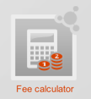
If confidentiality is required, the registration fee will be more expensive and a justification has to be provided! Note that ECHA has issued in April 2016 a guidance document on confidentiality claims - this can be downloaded from the ECHA website - Data submission manuals or from the Library page of the Iron Platform website. A fee calculator plug-in is available. This plug-in assists Legal Entities in calculating fees associated to REACH or CLP dossiers.

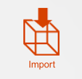
Member registrants will have to import all IUCLID files [reference substances and the file containing the uses] provided by the REACH Boron consortium before creating their substance files. Click here to download all i6z files.

An IUCLID 6 dissemination preview plug-in is available. This allows a registrant to preview or simulate the information from its registration dossier that ECHA will make available via the internet. You can find more information on disseminated data in the ECHA Dissemination and confidentiality under REACH regulation (April 2016) and its Transition to the new IT tools (March 2016).
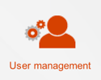
Important: Before starting to complete the IUCLID 6 file, go to the User management and ensure under Administration that the Legal Entity corresponds to the one registering the substance and is assigned as “(working)” [See screenshot].

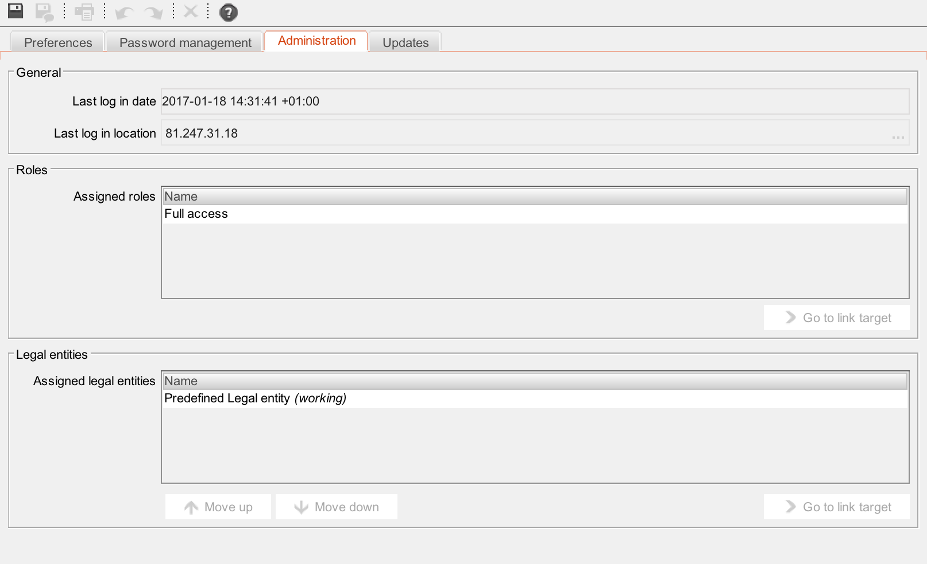

SUBSTANCE RELATED INFORMATION

1. GENERAL INFORMATION

1.1 Identification
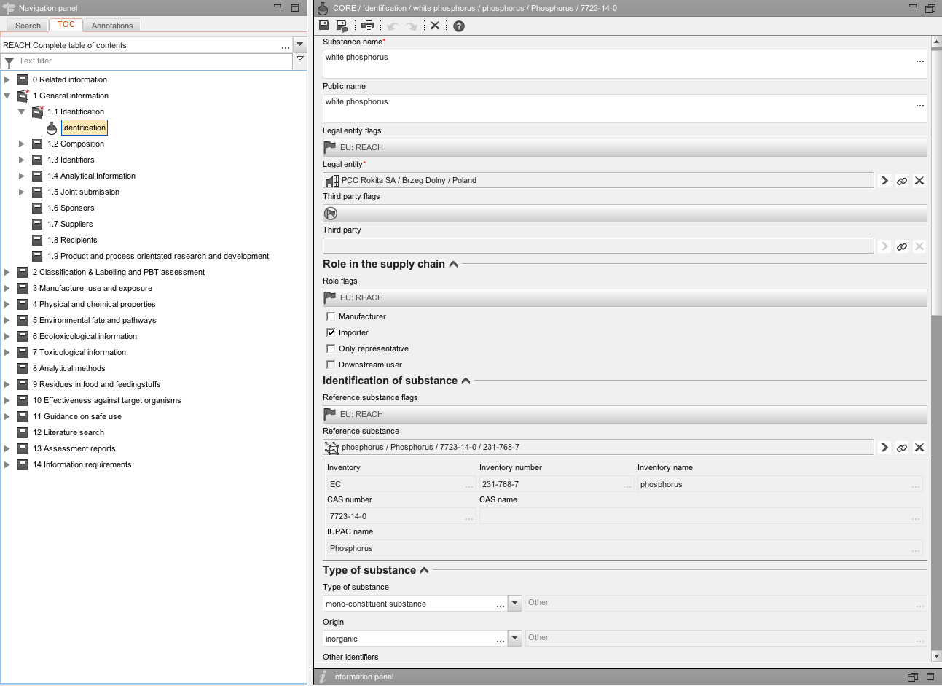
ITEM | TEXT TO BE ADDED | EXPLANATION
Identification | Heading only
Substance name | Phosphorus
Public name |  | We suggest that “Elemental phosphorus in alloys” be entered in this field.
Legal entity or third party flags: |  | Click on the flag if you want to assign confidentiality and programme restrictions.
Confidentiality |  | Leave blank or select the right level of confidentiality. If confidentiality is required, a justification has to be provided.
Programme restrictions |  | Select EU: REACH from pick list.
Role in the supply chain |  | Choose your role and tick appropriate box. Note:  If “manufacturer is selected, a production site is needed in section 3.3  Note that “only representative” cannot be selected together with “manufacturer” or “importer”
Role flags |  | Click on the flag if you want to assign confidentiality and programme restriction
Confidentiality |  | Leave blank or select the right level of confidentiality. If confidentiality is required, a justification has to be provided.
Programme restrictions |  | Select EU: REACH from pick list.
Identification of substance | Heading only
Reference substance flag |  | Click on the flag if you want to assign confidentiality and programme restrictions.
Confidentiality |  | Leave blank or select the right level of confidentiality. If confidentiality is required, a justification has to be provided.
Programme restrictions |  | Select EU: REACH from pick list.
Reference substance | phosphorus / Phosphorus / 7723-14-0 / 231-768-7 | To locate the reference substance from the IUCLID data base, click on this icon [see red arrow in screenshot above].  Select your substance from the database by typing in the name, EC or CAS number, click SEARCH, select the substance name and click Assign [see screenshot below].  Two problems may arise:  • If no entry is found, you have first to import the substance from the EC inventory to the reference substance inventory.  • If an entry is found but is inactive, right mouse click and set to “active reference substance.”  In order to simplify matters, the REACH Boron Consortium has provided reference substance files which member registrants can import into their IUCLID (see Note 1 below).
Inventory / number / name |  | This information is automatically provided when the reference substance is assigned.
CAS number / name |  | This information is automatically provided when the reference substance is assigned.
IUPAC name |  | This information is automatically provided when the reference substance is assigned.
Type of substance: | Heading only
Type of substance | mono constituent substance | Select from the pick list
Origin | element | Select from the pick list
Other identifiers | Heading only | Click on
Flags: |  | Click on the flag if you want to assign confidentiality and programme restriction
Confidentiality |  | Leave blank or select the right level of confidentiality. If confidentiality is required, a justification has to be provided.
Programme restrictions |  | Select EU: REACH from pick list.
Identifier |  | Select trade names, if you have trade name[s] for your substance.
Identity |  | If you have trade name[s] for your substance, add it/them here
Country |  | Select countries, were the trade names are being used.
Contact person |  | These fields are for your own company information. The details entered should correspond with the information contained in REACH-IT. Several contacts can be provided. Click on to add one.

Note 1
The reference substance for phosphorus (phosphorus / Phosphorus / 7723-14-0 / 231-768-7) developed by the Lead Registrant contains the following data. It can be downloaded on the REACH Boron Consortium website (by clicking here) and directly imported into your IUCLID database:

General information | Heading only
Reference substance name | Phosphorus
Inventory | Heading only
Inventory number | EC / 231-768-7 / phosphorus / 7723-14-0 / P
Reference substance information | Heading only
Reference substance flag | EU: REACH
IUPAC name | Phosphorus
Description | Leave blank
Synonyms | Phosphorus
CAS number | 7723-14-0
CAS name | Phosphorus
IUPAC name | Phosphorus
Identifiers of related substances | Leave blank
Group / category information | DSL Category: Inorganics
Related CAS information | Leave blank
Group / category information | Leave blank
Molecular & Structural information | Heading only
Molecular formula | P
Molecular weight range | 30.974
SMILES notation | [P]
InChl | Leave blank
Structural formula | P
Remarks | Leave blank

1.2 Composition

The records containing the boundary compositions for White/Yellow phosphorus and Elemental phosphorus in alloys (massive form/powder) form are already included. No adaptations should be made to these records. To include the legal entity composition of the forms of phosphorus you intend to register, you can make a copy of the corresponding boundary composition files by right clicking and copying the record and adjust as described below: White/Yellow phosphorus and Elemental phosphorus in alloys (massive form/powder).

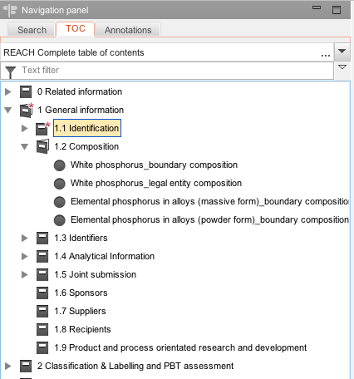

1.2.1 Composition – Elemental phosphorus in ferro-phosphorus alloys

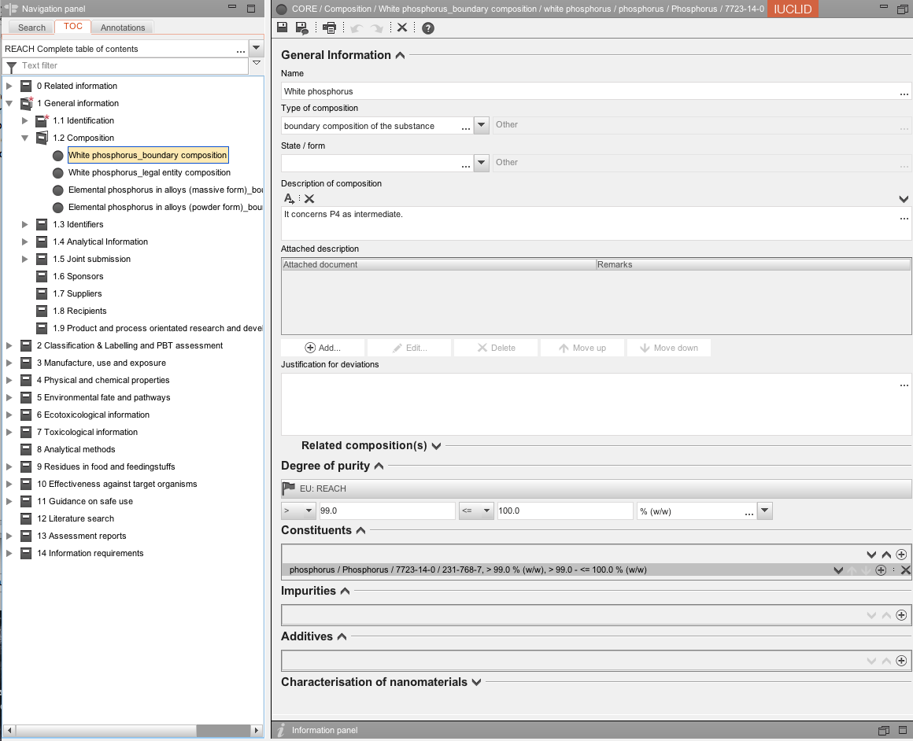

ITEM | TEXT TO BE ADDED | EXPLANATION
General information | Heading only
Name | Elemental phosphorus in ferro-phosphorus alloys
Type of composition | Legal entity composition
State / form | Solid: particulate/powder
Description of composition | It concerns P4 as intermediate. | Enter the suggested text
Attached descriptions | Leave blank
Justification for deviations | Leave blank
Related compositions | Leave blank
Degree of purity flags: | Heading only | Click on the flag if you want to assign confidentiality and programme restriction
Confidentiality |  | Leave blank or select the right level of confidentiality. If confidentiality is required, a justification has to be provided.
Programme restrictions |  | Select EU: REACH from pick list.
Degree of purity | ≥ 99 ≤ 100 % [w/w] | Elemental phosphorus contained in alloys is considered 100% pure.
Constituents | Heading only
Reference substance | phosphorus / Phosphorus / 7723-14-0 / 231-768-7 | To locate the reference substance from the IUCLID data base, click on this icon [see red arrow in screenshot above].  Select your substance from the database by typing in the name, EC or CAS number, click SEARCH, select the substance name and click Assign [see screenshot below].  Two problems may arise:  • If no entry is found, you have first to import the substance from the EC inventory to the reference substance inventory.  • If an entry is found but is inactive, right mouse click and set to “active reference substance.”  In order to simplify matters, the REACH Boron Consortium has provided reference substance files which member registrants can import into their IUCLID dossiers (see Note 1 on page 6 above).
Typical concentration | > 99 % [w/w] | In order to be consistent with the approach taken by the Lead Registrant 100% [w/w%] should be entered in this field.
Concentration range | ≥ 99 ≤ 100 % [w/w] | This is per the sameness specification agreed by the SIEF.
Remarks | It concerns P4 as intermediate | Recommended text for alloys
Impurities | Heading only | Do not create a block here
Additives | Heading only | Do not create a block here
Characterisation of nanomaterial | Heading only | Not applicable, leave all items under nanomaterials blank

1.2.2 Composition – Elemental phosphorus in alloys (massive form / powder form)

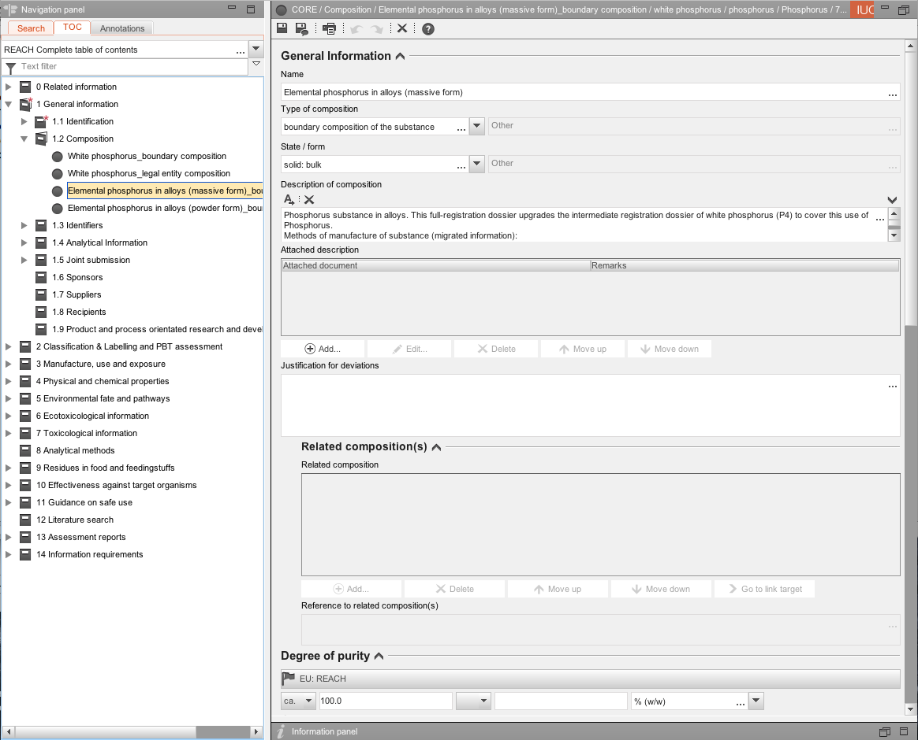
ITEM | TEXT TO BE ADDED | EXPLANATION
General information | Heading only
Name | Elemental phosphorus in alloys (massive form)
 | Elemental phosphorus in alloys (powder form)
Type of composition | Legal entity composition
State / form | Solid: bulk
 | Solid: particulate/powder
Description of composition | Phosphorus substance in alloys. This full-registration dossier upgrades the intermediate registration dossier of white phosphorus (P4) to cover this use of Phosphorus.  Methods of manufacture of substance:  Elemental phosphorus contained in ferro-phosphorus -  Ferro-phosphorus is a by-product of the production of white phosphorus (P4) in an electric (submerged) arc furnace. Raw materials are phosphate pellets, silica gravel and dried coke. During the phosphorus reaction, the feed mixture is converted into gaseous product (mainly P4 and CO) and a liquid calcium silicates slag (CaSiO3 and Ca4Si2O7F).  In addition, a second liquid product, known as ferro-phosphorus, is also produced. Iron oxides contained in the phosphate ore are reduced to metallic iron which reacts with the P4 to form ferro-phosphorus.  The ferro-phosphorus with its high specific gravity collects in the bottom of the furnace and is tapped daily, collected in a sand bed and cooled with water and air. | Enter the suggested text
Attached descriptions | Leave blank
Justification for deviations | Leave blank
Related compositions | Leave blank
Degree of purity flags: | Heading only | Click on the flag if you want to assign confidentiality and programme restriction
Confidentiality |  | Leave blank or select the right level of confidentiality. If confidentiality is required, a justification has to be provided.
Programme restrictions |  | Select EU: REACH from pick list.
Degree of purity | ca. 100 % [w/w] | Elemental phosphorus contained in alloys is considered 100% pure .
Constituents | Heading only
Reference substance | phosphorus / Phosphorus / 7723-14-0 / 231-768-7 | To locate the reference substance from the IUCLID data base, click on this icon [see red arrow in screenshot above].  Select your substance from the database by typing in the name, EC or CAS number, click SEARCH, select the substance name and click Assign [see screenshot below].  Two problems may arise:  • If no entry is found, you have first to import the substance from the EC inventory to the reference substance inventory.  • If an entry is found but is inactive, right mouse click and set to “active reference substance.”  In order to simplify matters, the REACH Boron Consortium has provided reference substance files which member registrants can import into their IUCLID dossiers (see Note 1 on page 6 above).
Typical concentration | ca. 100 % [w/w] | Enter the typical concentration of boron in your registered boron powder(s)
Concentration range | ≥ 80 ≤ 100 % [w/w] | This is per the sameness specification agreed by the SIEF.
Remarks | Alloys (REACH Article 3(41)) are special type of mixture ‘special mixture’ (Recital 31, Annex I and Annex II). Only the individual substances (here metals) require registration (REACH article 6) and not the alloys themselves. As the substance is part of the chemical matrix of an alloy, impurities cannot be meaningfully assigned to the substance. Thus, the purity of the substance is 100%. | Recommended text for alloys
Impurities | Heading only | Do not create a block here
Additives | Heading only | Do not create a block here
Characterisation of nanomaterial | Heading only | Not applicable, leave all items under nanomaterials blank

1.3 Identifiers

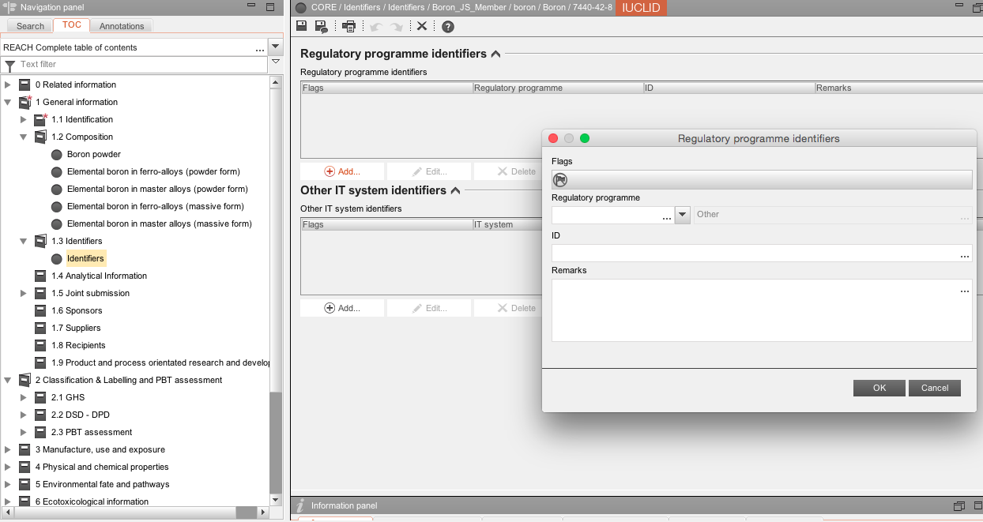
ITEM | TEXT TO BE ADDED | EXPLANATION
Regulatory programme identifiers | Heading only | Click on
Flag | Heading only | Click on the flag if you want to assign confidentiality and programme restrictions.
Regulatory programme |  | Select REACH Pre-registration number and/or REACH registration number from the pick list.
ID |  | Enter your pre-registration and/or registration number.
Remarks | We have updated our pre-registration as producers and importers of phosphorus-containing mixtures [alloys] will register phosphorus [Einecs number 231-768-7, CAS number 7723-14-0] and the other alloying elements separately as components of a mixture [alloy]. | In the case that you did not pre-register phosphorus [EC number 231-768-7, CAS number 7723-14-0], but for example you pre-registered iron phosphide, EC number 235-798-1, CAS number 12751-22-3, please add this remark.
Other IT system identifiers |  | Leave blank

1.4 Analytical information

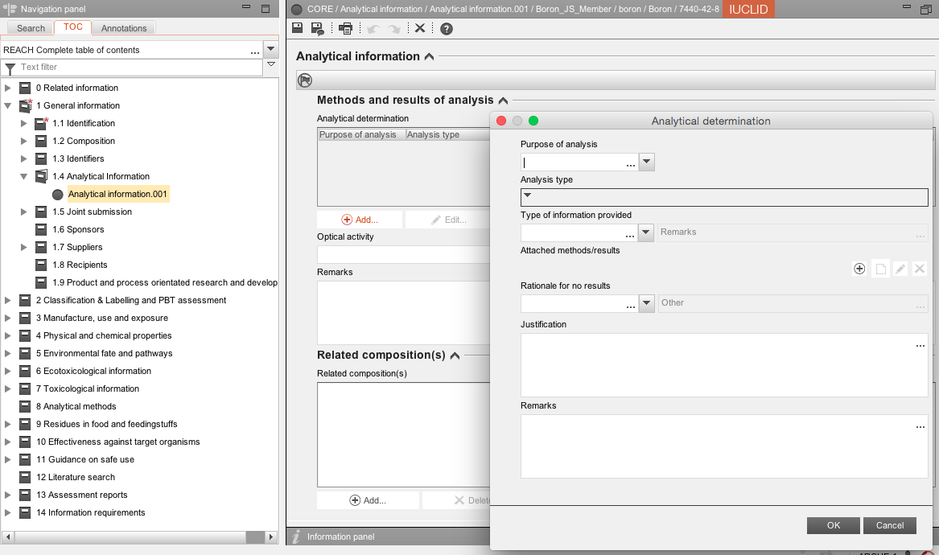

ITEM | TEXT TO BE ADDED | EXPLANATION
Analytical information flags: |  | Click on the flag if you want to assign confidentiality and programme restriction
Confidentiality |  | Leave blank or select the right level of confidentiality. If confidentiality is required, a justification has to be provided.
Programme restrictions |  | Select EU: REACH from pick list.
Methods and results of analysis | Heading only
Analytical determination | Heading only | Click on
Purpose of analysis |  | You must analyse your phosphorus alloy to confirm sameness. Select the appropriate end result from the performed analytics
Analysis type |  | Select the analysis method used
Type of information provided |  | Select the type of information
Attached methods/results |  | Attach a document describing your analysis method and/or results here.
Rationale for no results | Leave blank
Justification | Leave blank
Remarks | The constituent substances are bound in a chemical matrix. Methods such as XRF, XRD and ICP are appropriate techniques. While it may provide structural information concerning the alloy, XRD is unlikely to yield sameness information. | For consistency reasons, we ask all registrants to include the statement.
Optical activity | Not applicable
Remarks | The registered substance is inorganic and a constituent of an alloy, where the constituent substances are bound in the chemical matrix. GC, HPLC, IR, NMR, MS and UV are not appropriate spectral techniques for alloys. Methods such as XRF, XRD and ICP are more appropriate techniques for the provision of the required structural and compositional information for this type of inorganic substance and a usual practice in the metals industry. However, while it may provide structural information concerning the alloy, XRD is unlikely to yield information useful for the determination of the sameness of the constituent and reference substances. This is due to the influence of the relative atomic size of the constituents, which determine the crystal structure adopted by the alloy, the extent of lattice strain and the range of solid solubility as well as the position taken up by individual atoms either in the lattice itself or in the interstice. In addition, the cooling rate as well as the thermal and mechanical history has a profound influence on the crystal structure of the alloy. | Include this remark.
Related composition(s) | Heading only | Create a block for each type of boron you wish to register by clicking on.

Note: The Lead Registrant also included here in its dossier the following document on the sameness criteria for phosphorus alloys:

1.5 Joint submission

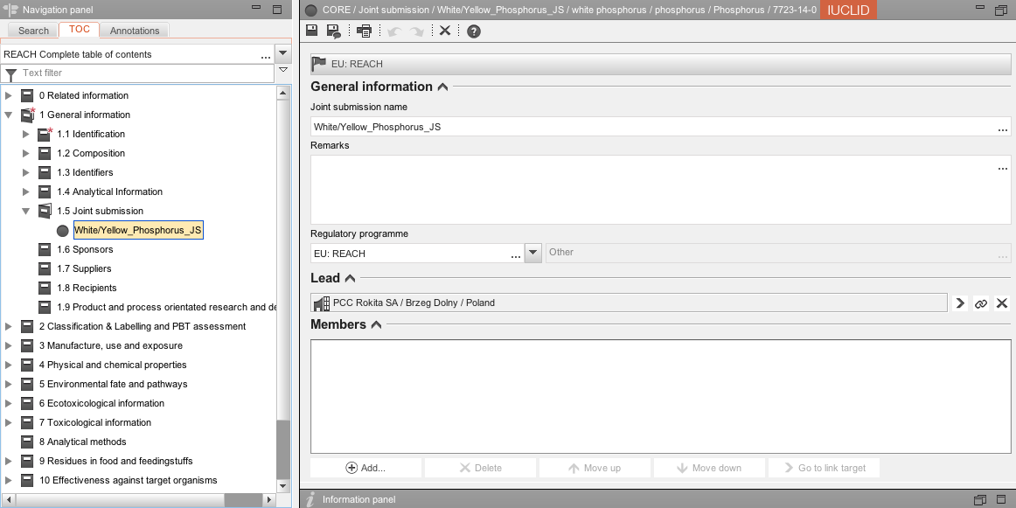
ITEM | TEXT TO BE ADDED | EXPLANATION
Joint submission | Heading only
Joint submission flags: |  | Click on the flag if you want to assign confidentiality and programme restriction
confidentiality |  | Leave blank or select the right level of confidentiality. If confidentiality is required, a justification has to be provided.
programme restrictions |  | Select EU: REACH from pick list.
General information
Joint submission name | White/Yellow_Phosphorus_JS
Remarks |  | Leave blank
Regulatory programme |  | Select EU: REACH.
Lead | Heading only | Leave blank
Members | Heading only | Leave blank

1.6 Sponsors

It enables to specify different Sponsor organisations, e.g. a Competent Authority in the context of the OECD HPV Chemicals programme or a Company in the context of the US EPA HPV Challenge programme. Otherwise leave this section blank.

1.7 Suppliers

Leave this section blank unless you are an Only Representative. Although not mandatory, ECHA recommends that as an Only Representative you should attach clear documentation of your appointment as Only Representative, for example a copy of the appointment letter sent to importers. In this case you are also advised to indicate the list of importers’ names covered by the registration in the field “Other importers”. The REACH Boron Consortium strongly advises Only Representatives to follow ECHA’s recommendation.
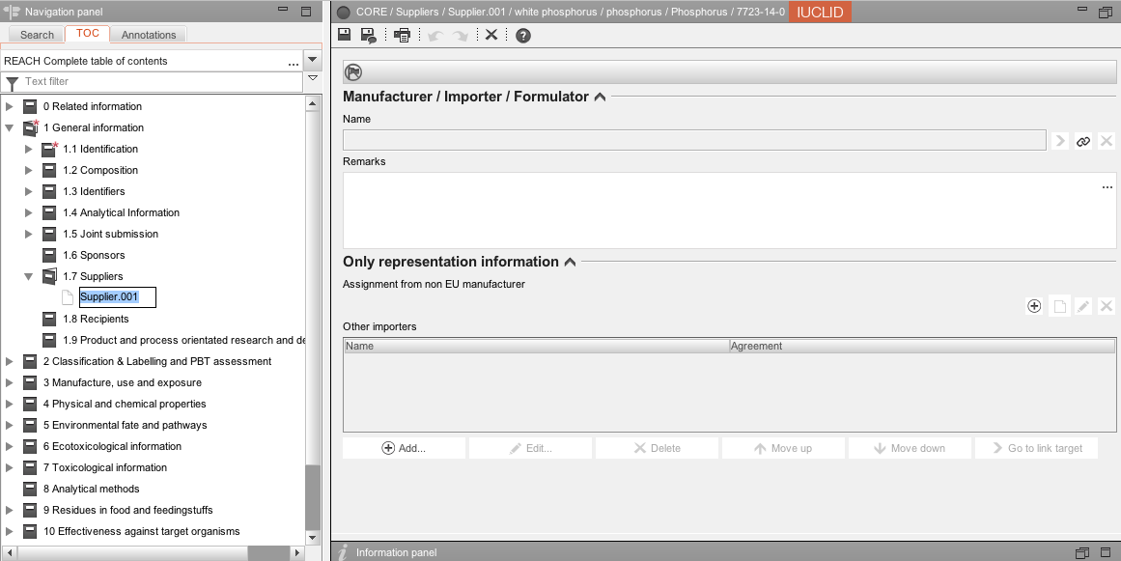

1.8 Recipients

A recipient can be a Downstream user, a Distributor or a Customer (e.g. in the context of Product and process orientated research and development (PPORD)) being supplied with a Substance, or a Mixture or an Article. These definitions never include consumers.

3. MANUFACTURE, USE AND EXPOSURE
3.2 Estimated quantities

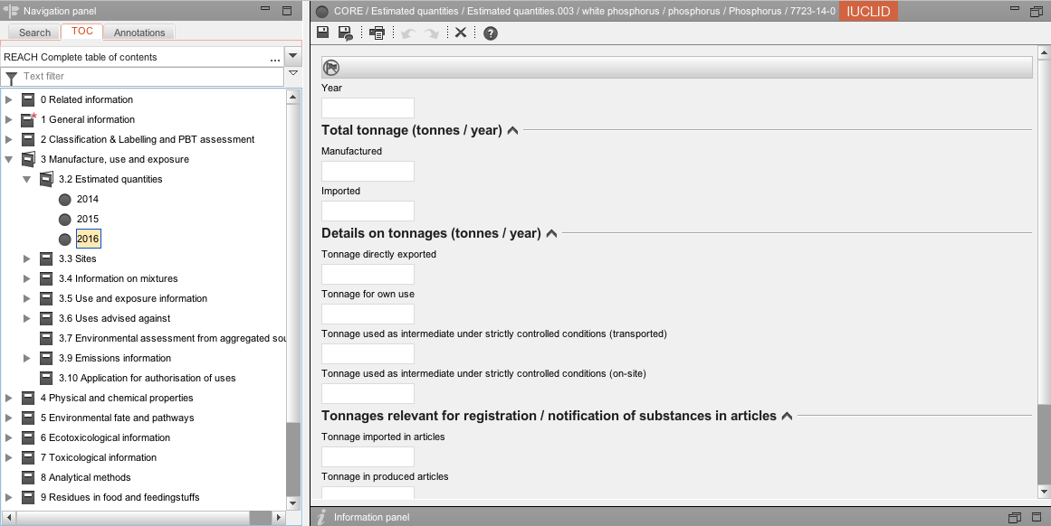

Make endpoint study records for the last three years by clicking right and selecting new record.

ITEM | TEXT TO BE ADDED | EXPLANATION
Estimated quantities flags: |  | Click on the flag if you want to assign confidentiality and programme restriction
confidentiality |  | Leave blank or select the right level of confidentiality. If confidentiality is required, a justification has to be provided.
programme restrictions |  | Select EU: REACH from pick list.
Year |  | Enter the current year
Total tonnage |  | If the substance has been imported or manufactured for at least three consecutive years, the volume (tonnes per year) is calculated on the basis of the average tonnage manufactured or imported in the three preceding calendar years. If the substance has not been manufactured or imported for three consecutive years then the tonnes manufactured or imported in a calendar year should be used (see ECHA guidance on registration, November 2016)  To determine the amount of a substance in an article or mixture, see the notes immediately below.
Details on tonnages |  | If you feel the need to provide an explanation for the basis of your tonnage, include it here.
Tonnages relevant for registration |  | If you feel the need to provide an explanation for the basis of your tonnage, include it here.

Amount of a substance in a mixture
In order to be able to calculate the amount of a substance in a mixture, the total tonnage of the mixture is multiplied by the fraction of the constituent substance. This value can for example be obtained from the safety data sheet of the mixture. When only a range of concentrations of a substance in a mixture is available, then the maximum tonnage of the substance is calculated using the highest possible content of that substance in the mixture. Without more precise information on the composition, this tonnage should be used for the purpose of registration.
Source: ECHA Guidance: Guidance on registration, version 3.0, November 2016

Amount of a substance in an article
In the case of articles which contain a substance that is intended to be released under normal or reasonably foreseeable conditions of use, then:
- If the weight by weight content of that substance is known, then this value is multiplied by the total mass of the produced and/or imported article; or
- If the weight of substance per unit article is known then this value is multiplied by the total number of imported articles.
Source: ECHA Guidance: Guidance on requirements for substances in articles, version 3.0, December 2015

3.3 Sites
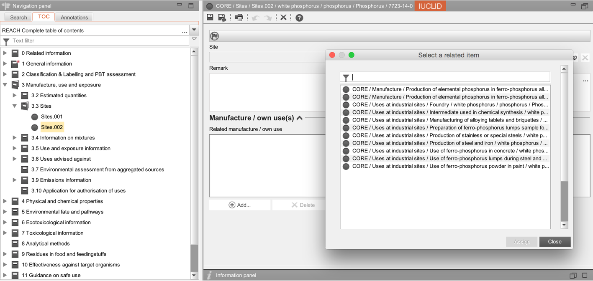
Create a new record for each production site by clicking right and selecting new record.
ITEM | TEXT TO BE ADDED | EXPLANATION
Site flags: |  | Click on the flag if you want to assign confidentiality and programme restriction
Confidentiality |  | Leave blank or select the right level of confidentiality. If confidentiality is required, a justification has to be provided.
Programme restrictions |  | Select EU: REACH from pick list.
Site |  | Click on to select an existing site or create a new site  Enter the name and location of your site(s). The minimum contact address information is town/city and country, but ECHA recommends filling all address fields.  An Only Representative or Importer can assign a site, but this is not mandatory.  If “Manufacturer” is selected in section 1.1, at least one production site must be entered in section 3.3.
Manufacture/own use(s) |  | Create a block. Click on Select appropriate manufacture(s) or use(s) from the section 3.5 Use and exposure information description.

3.4 Information on mixtures

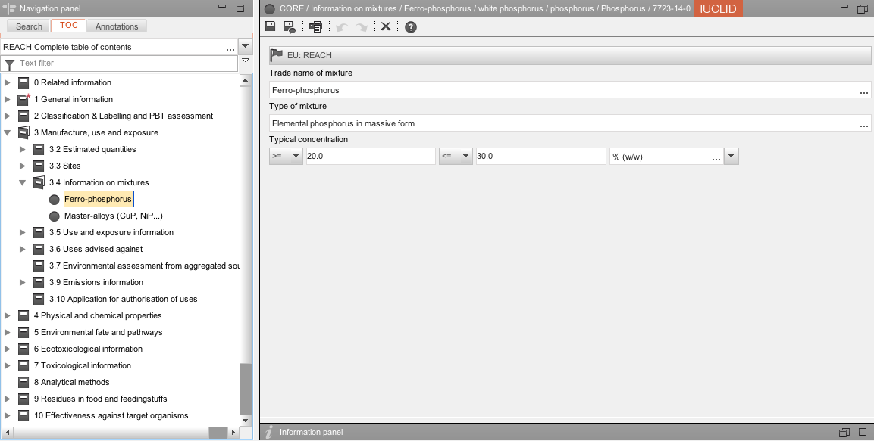

ITEM | TEXT TO BE ADDED | EXPLANATION
Flags |  | Click on the flag if you want to assign confidentiality and programme restrictions
Confidentiality |  | Leave blank or select the right level of confidentiality. If confidentiality is required, a justification has to be provided.
Programme restrictions |  | Select EU: REACH from pick list.
Trade name of mixture |  | Give the name of your alloy[s], e.g. ferro-phosphorus, etc.
Type of mixture |  | State the physical form of your alloy, e.g. massive, powder.
Typical concentration |  | Specify the content of phosphorus contained in your alloys[s] - this can be a range or by default the maximum value. Ensure that the content given e.g. for iron is consistent with the value[s] for iron given in other registration dossiers for this alloy.

3.5 Use and exposure information

Uses covered by the Lead Registrant dossier are available on the REACH Boron consortium website. An i6z file containing the “Use and exposure information” endpoints of the Lead Registrant (LR) can be downloaded from the REACH Boron consortium website by clicking here.

We recommend you to:
- import the i6z file containing the uses covered by the LR dossier into your IUCLID application
- copy the full “3.5 Use and exposure information” endpoints of the LR to your phosphorus substance dataset

There is conflicting advice as to whether member registrants should select only certain uses submitted by the Lead Registrant or should select them all. We advise you to select them all to avoid a modification of your dossier if a new use arises in the future.

Important:
All the uses submitted by the Lead Registrant (LR) are included in the joint Chemical Safety Report submitted by the LR on behalf of the members. If one of your manufacture/uses/service life is not covered in the LR dossier, we strongly advise you to contact the REACH Boron Consortium as soon as possible. Note that if you wish to specify uses not included in the LR dossier, you need to carry out your own Chemical Safety Assessment for the uses, conditions of use and related volumes not covered in the joint Chemical Safety Report.

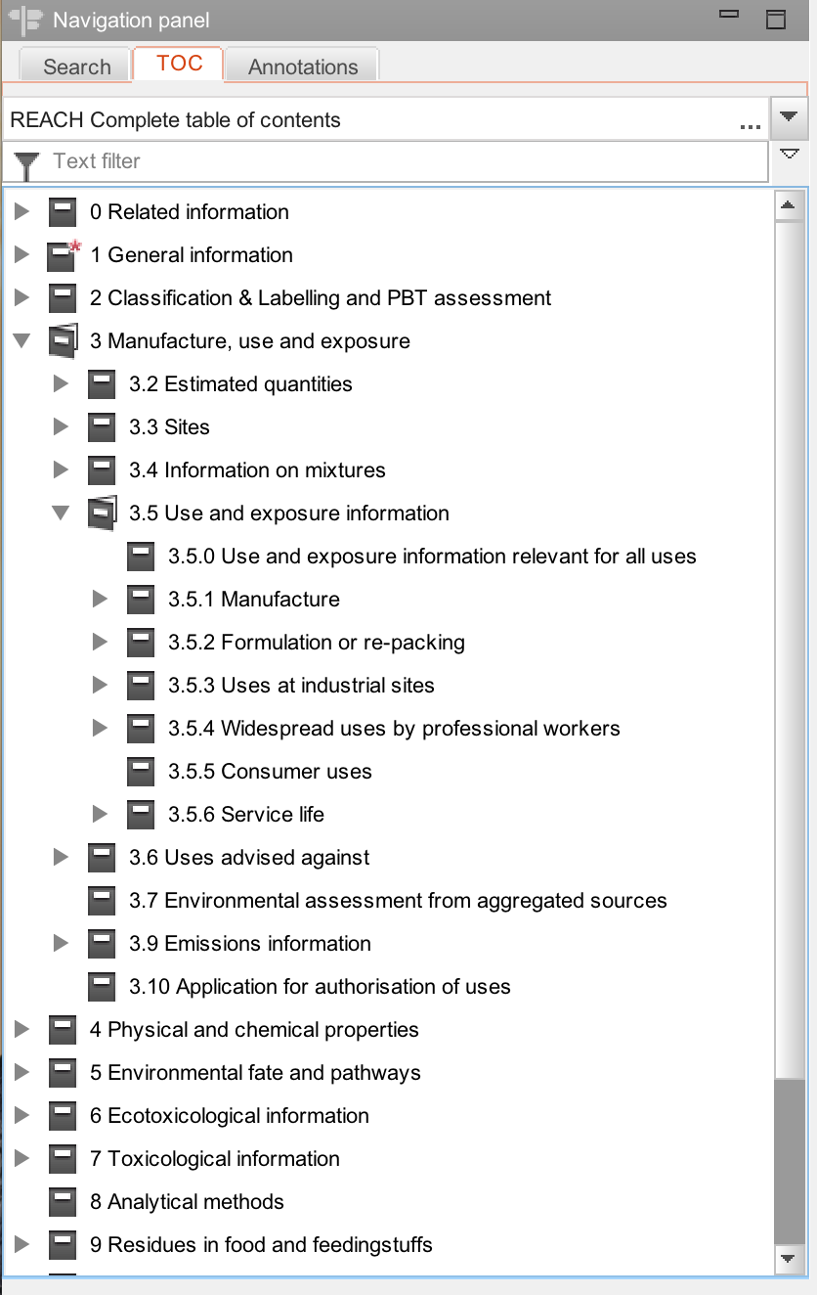

3.6 Uses advised against
Do not create a record in Section 3.6 and leave it blank as there are no uses advised against.

3.7 Environmental assessment for aggregated sources
Do not create a record in Section 3.7 and leave it blank.

3.9 Emissions information
Do not create a record in Section 3.9 and leave it blank.

3.10 Application for authorisation of uses
Do not create a record in Section 3.10 and leave it blank.

11. GUIDANCE ON SAFE USE
Leave blank; do not create an endpoint. The Guidance on Safe Use is provided by the Lead registrant on-behalf of all member registrants.

13. ASSESSMENT REPORTS

The Lead Registrant provided the part B of the CSR on behalf of all member registrants. Member registrants must attach their own part A of the CSR. A draft of the CSR part A can be found on the Consortium website. Review it and amend it accordingly. Create an endpoint named ‘own CSR part A’ in the section 13 as recommended by ECHA and attach your part A of the CSR as a pdf file in the section 13.

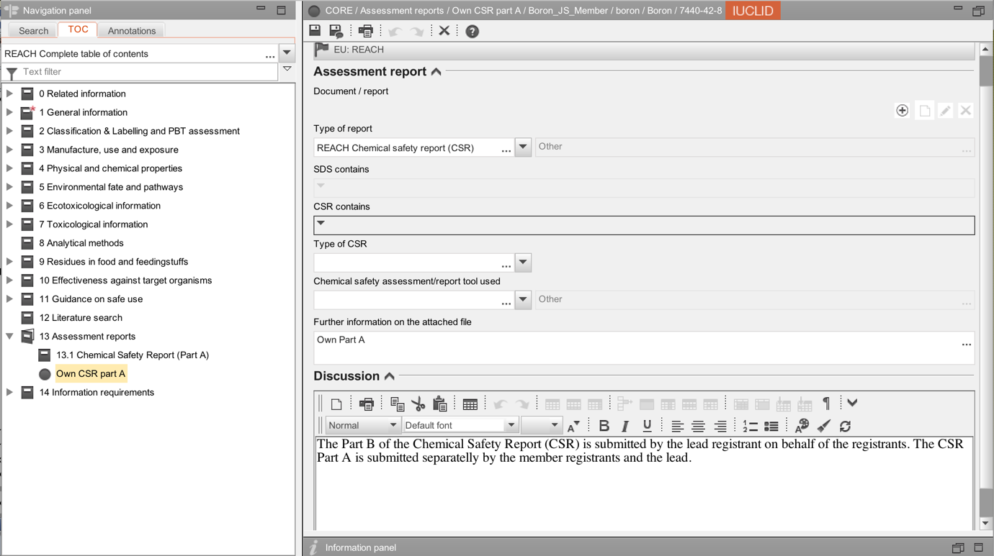

- DOSSIER RELATED INFORMATION
Important:
1. Run the Validation Assistant (VA) on your IUCLID substance file:
- If VA fails, correct all mistakes or create a new substance file
- If VA passes, go to the next step
2. Select the appropriate substance, right click and select “Create dossier…” as displayed on the following screenshot and follow the dossier creation wizard guide

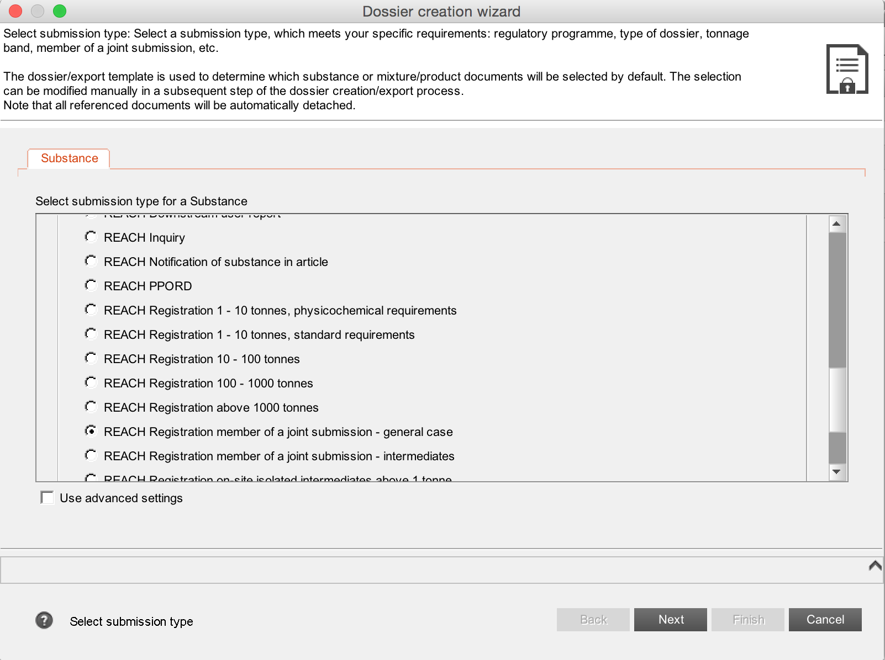
Select the dossier template for member of a Joint Submission

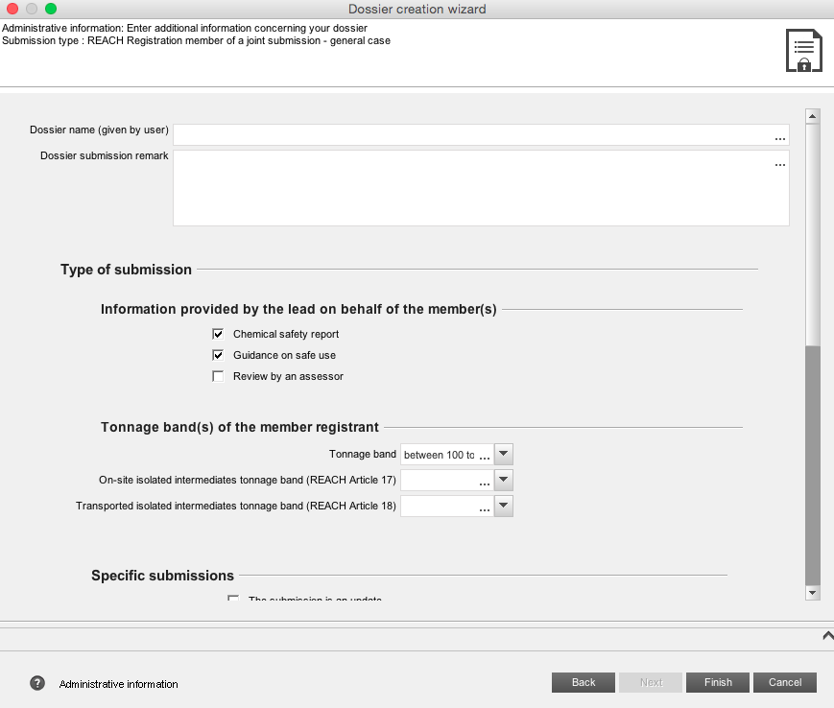
NOTE: The CSR part B is provided by the Lead Registrant for Phosphorus. This box should be ticked even if you are submitting your own part A. See further information in the ECHA Data Submission Manual 19: How to submit a CSR as part of a joint submission? (September 2010)

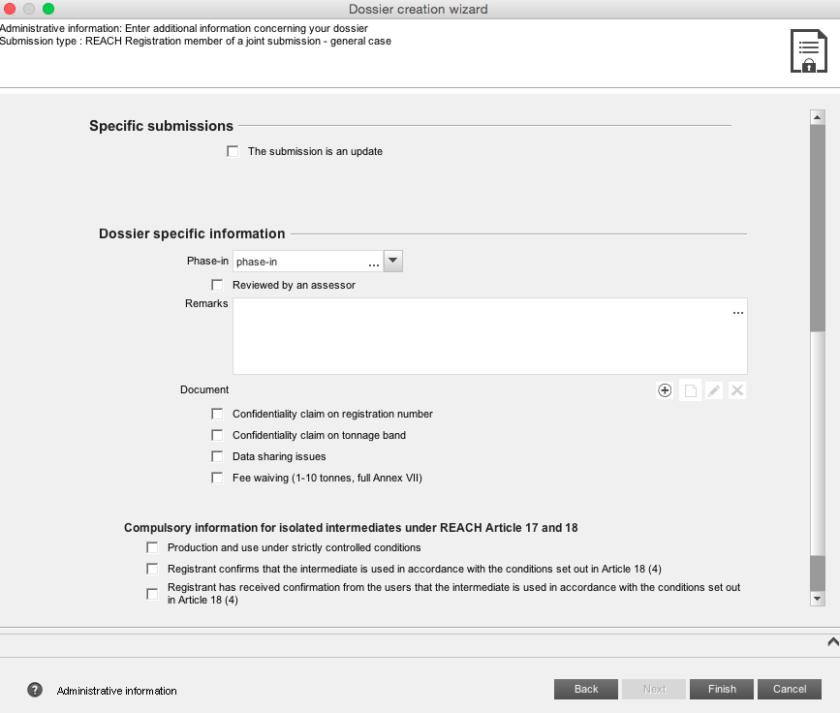
Tick the box(es) if you wish to claim confidentiality on registration number or tonnage band. Note that this will increase the registration fees.

- RECOMMENDATIONS CONCERNING SUBMISSION

Before submitting your dossier, do not forget to:
- Run the VA on your IUCLID dossier file
- If VA fails, create a new dossier file
- If VA passes, go to the next step
- Export your dossier file on your computer by right clicking on the dossier
- Login on your ECHA REACH-IT account specific to the Legal Entity
- If the dossier file size is larger than 20MB => request a large file access code before submission on ECHA REACH-IT [it is normally immediate and you will receive the code in your ECHA REACH-IT message box]
- Follow the prompts to submit your dossier file [for more detailed information, please consult the ECHA Guidance on Registration (November 2016)

After submission:
- Check your message box in ECHA REACH-IT to follow progress of ECHA’s 14 dossier examination steps via the submission report. You can define an option in the User Preferences to receive an email alert when an email is sent on your REACH-IT mail box.
- Take the necessary actions, for example paying the registration fee.

Disclaimer: The REACH Boron Consortium and Boron Consortium Services Ltd. do not make any representations or warranties in relation to the content of this guidance document. In particular, the REACH Boron Consortium and Boron Consortium Services Ltd. do not make any representations or warranties regarding the accuracy, timeliness or completeness of its content. The REACH Boron Consortium and Boron Consortium Services Ltd. will not be responsible for any loss or damage caused by relying on the content contained in this document.

Guidance version

Date | Version - Main changes
December 2012 | First draft
March 2013 | First version
May 2017 | Revision for compliance with IUCLID 6

